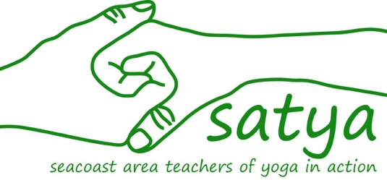

Please record any donations you have received in cash or check (payable to “SATYA”) that you are bringing to the Yoga Mala. We will add it to your total!

Checks (payable to “SATYA”) may be mailed to: PO Box 265 Greenland, NH 03840

Thank you for your fundraising efforts!

Your Name:

Your Team Name (if applicable):

Donor’s Name | Amount | Cash or Check

TOTAL:

